**February, 5 2017**

**Volume 1, Issue 2**

Mission Control PTA

Box tops are popping up everywhere! We are halfway through our box top contest and it is going strong. Students have been bringing back their box top sheets filled with box tops earning points for their class. We had many Rockets take advantage and bring their box tops to our PTA meeting January, 31 and earn double points for their class! At the half way point our leader is Mrs. Jones! Not far behind are Mrs. Owens and Mrs. Hammill. Remember that every box top helps us reach our goal of 10,000 box tops turned. The class that has the most box tops turned in will earn a popcorn and movie party! Box tops are a great way for RES families to help earn money for our school. Our box top contest will end on February, 17. Until then keep clipping and saving those box tops!

***Upcoming:***

**Feb 23rd 5-7 , Family Night**

**March 28th 5-7, Marvelous Math**

**Box Top ends Feb 17th**

**Vday Grams FEB 6-10th**

**Honor Roll Tea**

**Feb 10th**

**Fundraiser**

**March 10-24**

*PTA is very excited for our upcoming family night February,23rd from 5-7. Come and shop the book fair with your rocket/ rockets before joining us in the cafeteria for some family fun. Bingo for books, crafts, photo booths and face painting will be set up in the cafeteria ready for families to enjoy. Make sure you come hungry! We will have hotdogs provided by hotdog shack, chips, drinks and a dessert. Family Night packs will go on sale this week and will be $5 a person or $20 for families of four or more. The Family Night packs will include a hotdog meal, bingo for books, craft supplies, photo booth and face painting. An RSVP will come home this week with students. You may return your RSVP with your payment or pay online. Families who pre purchase their family night packs will be entered in a drawing for $15 in book fair bucks to be used on family night. We will only order a few extra hotdogs so be sure to RSVP and join us for some family fun. The class that has the most students come to Family Night will earn an extra recess! We look forward to seeing everyone!*

**Current Sponsors**



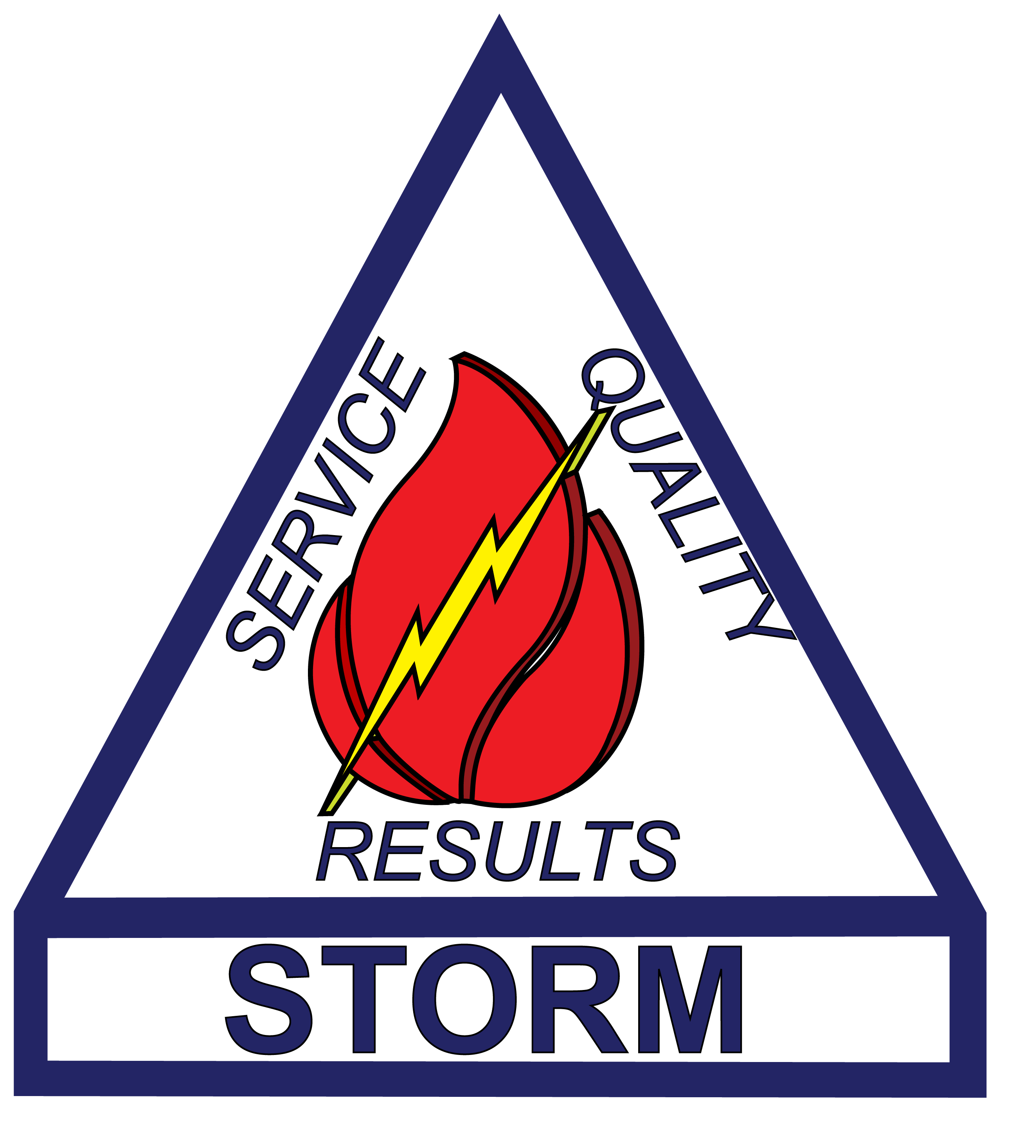

***Social Media***

***F- Mission Control PTA***

***T- @RES_MCPTA***

***Email- sponsorshipsmcpta@gmail.com***

***Phone- TBD***

***Website: http://res.rss.k12.nc.us/pta***

## Box Top Contest

Written by: Natalie Cochran

# Rockwell Rockets Family Night



Mission Control has been working very hard to make RES the best for all of our rockets. It takes a strong team of volunteers to help our rockets fly. We appreciate all of our PTA members and want to take a chance to give a special thank you to a few of our members that have gone above and beyond.

December: Dallene Yontz Dallene is our hospitality committee chair and really worked hard during December to make the holidays magical at RES. She worked hard with Mission Control putting together the 12 days of Christmas for staff. Dallene also worked hard to put together a wonderful luncheon for our teachers with BBQ donated and cooked by her husband, Thank you Dale for all you do!

January: Victoria Smith

Victoria has worked hard since jumping feet first into PTA. She worked on our new website, opened up lines of communication with Dojo, Facebook and Twitter as well as planed our PTA membership meeting. We also love the new sprit wear that Victoria has brought to RES. Victoria has been a big part of launching Mission Control, Thanks Victoria, you will be missed.



## Don’t forget to get your new RES sprit magnet!

Oh the things you can find if you don’t stay behind!”

- Dr. Seuss

We have added many new members to PTA over the last month and we are thrilled. There are all types of ways to volunteer and help our rockets fly. Many of our committees offer opportunities to help before, during and after school. You can also volunteer from home or send in items to donate. Check out our committees and see which one works best for you!

Hospitality Committee: Organizes teacher lunches, teacher holiday gifts, treat days, teacher appreciation week, dessert donations, and meals for school visitors, etc.

Special Events Committee: Organizes family nights, PTA functions, donations for events, fundraising ideas and rewards, etc.

**Fall Festival Committee:**Planning for our 2017 Fall Festival will begin soon.We are looking to add to our festival and make it even better. PTA is looking for committee members and leaders to share ideas and begin planning to get us ready for festival fun.

Contact PTA if you are interested in join any of the committees. We look forward to new faces and new ideas.

## Volunteer of the Month

## Mission Control Committees and Volunteers